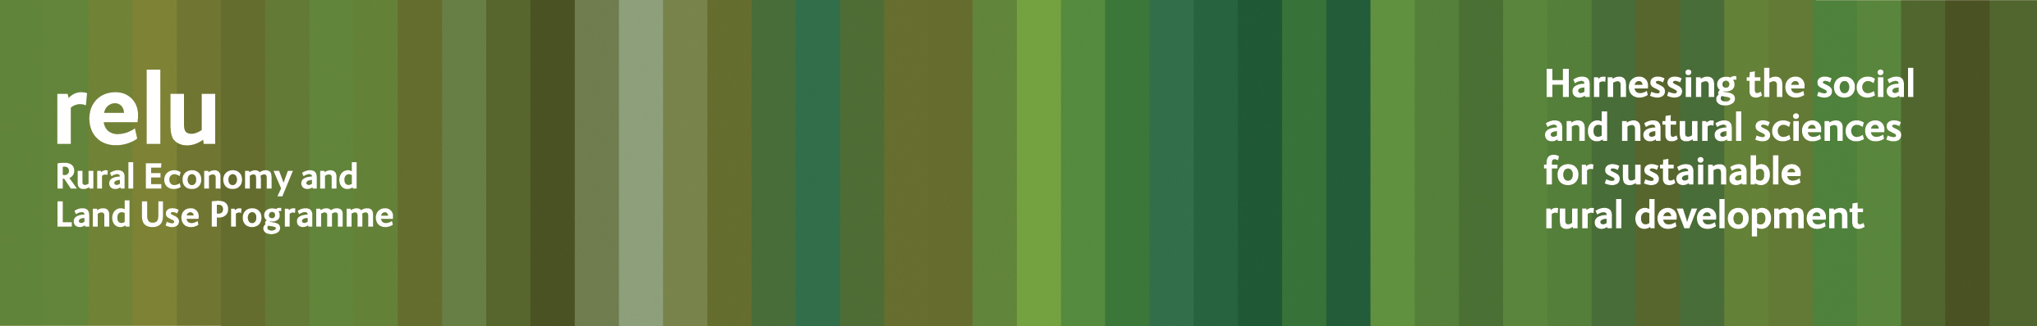
Press release
19 May 2009
Would eating five portions of fruit and vegetables a day really benefit everyone?

Eating more healthily might be better for us as individuals, but would it be bad news for farmers? A research project funded by the UK Research Councils’ Rural Economy and Land Use Programme had found that if we all followed government advice to eat five portions of fruit and vegetables a day this could have serious implications for the countryside.
The interdisciplinary team, led by Bruce Traill, Professor of Agricultural and Food Economics, at the University of Reading, set out to examine how the UK could produce healthy foods that consumers wish to buy at prices they are willing to pay and to assess the impact on land use and the rural environment and economy.
Their research shows that, if we assume that the percentage of imports will remain constant, many more hectares of intensive production under polythene tunnels would be needed in order to produce the quantity of fruit and vegetables for the recommended healthy diet.
At the same time, areas such as Wales and the south west, which are most suited to grazing animals rather than growing crops, would suffer a severe decline in such production. For example, in Wales, cattle numbers would fall by some 400,000 head and sheep numbers would be halved. In the north of England both sheep and cattle numbers would fall by 200,000 head each.
This could mean unemployment in, and abandonment of, upland areas. Smaller farms would disappear and be absorbed into larger land holdings. Upstream industries would suffer, particularly feed suppliers, and there would be a knock-on effect on the wider rural economy of the uplands.
Increased production of fruit and vegetables in the east and south east of England would be unlikely to bring more employment, as there is scope for use of machinery for many of the required horticultural operations and, where labour is required, farmers would probably rely on casual workers. Pressure would increase on water supplies because of the need to irrigate crops.
Professor Bruce Traill said: “Undoubtedly the UK Government has a duty to promote the health of the population and within this research project we have been looking at the most effective ways of doing that, whether by fiscal measures, social marketing, or by trying to enhance the nutritional qualities of the foods that people eat. There is potential in all of these approaches, if they are targeted effectively
“But we do also have to consider the potential unintended consequences of policies. For rural communities, such as the dairying industry of south west England and upland areas of the UK these could be far-reaching and need to be taken into account.”
Results from the research will be among the presentations at “The Future of Rural Land Use” conference on Thursday 4 June 2009, at Congress House, Great Russell Street in London.

Notes for editors:
1 For a summary of the research findings see http://www.relu.ac.uk/news/policy%20and%20practice%20n otes/PPN6%20Traill.pdf
- The Rural Economy and Land Use Programme is an interdisciplinary collaboration between the Economic and Social Research Council (ESRC), the Biotechnology and Biological Sciences Research Council (BBSRC) and the Natural Environment Research Council (NERC), with additional funding provided by the Scottish Government and the Department for Environment, Food and Rural Affairs. See www.relu.ac.uk for more information about the Relu programme.

- For further details of the Relu “Future of Rural Land Use” conference see http://www.relu.ac.uk/events/Conf%20June%202009/11064%20RELU%20A5%20Conf%20Invite%20Amended.pdf

- For more information contact Anne Liddon, Science Communications Manager, tel 0191 2226880 email anne.liddon@ncl.ac.uk.

- University of Reading - Department of Agricultural and Food Economics focuses on the economic, policy and wider societal questions connected to the production and consumption of food and fibre in developed and developing countries including the impacts in policy relevant areas such as rural poverty, international development, the environment and dietary health. www.reading.ac.uk/apd . More information from Alex Brannen, Media Relations Manager, on 0118 378 7388, a.brannen@reading.ac.uk

ends

